Our goal, initially, is to modify the optional processes requiring users' explicit consent for their execution.
Let's take the example of a personalized movie recommendation feature.

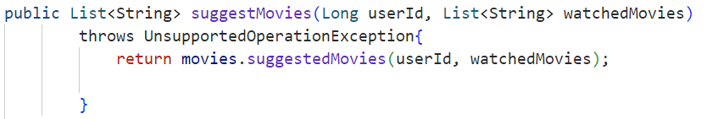

The goal is to verify whether the user, for whom we want to offer recommendations, has given their explicit consent before generating and presenting these suggestions.
This code checks, via the consent manager, whether the user (identified by "userId") has given their consent or not.
- Now, the code must be modified so that its execution directly depends on the response from getConsent() (see example).
- Remember that when annotating the processes, we defined the processingId as the class name followed by the method name (className.methodName). That’s why we added two variables: className and methodName, which respectively retrieve the class name and the method name.
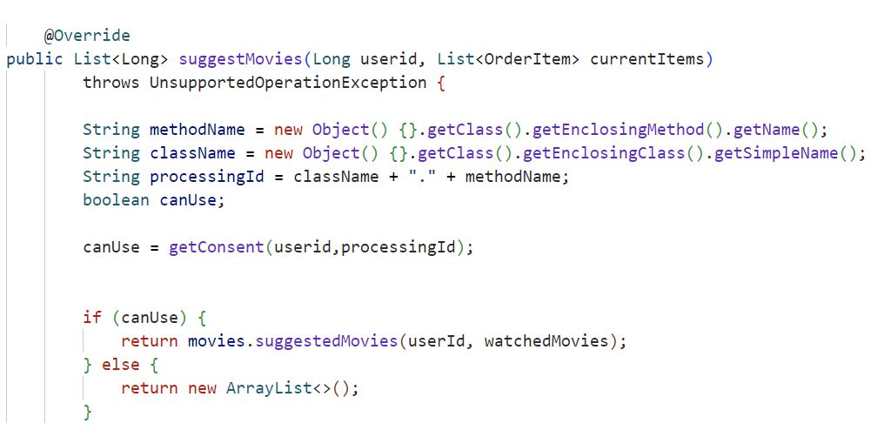

Note:
If the function takes a set of users as a parameter instead of a single user, this version of the code should be used:
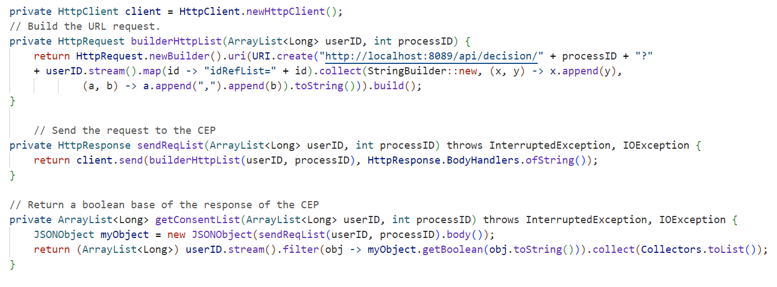
Note:
You might encounter an error if PRIAM and your application are not on the same network. In that case, remember to modify the URL by replacing "localhost" with the network to which your application belongs.

